**User Manual**

**Attendance Management System**

This is the front page of the system. Only admin and registered teacher can login.

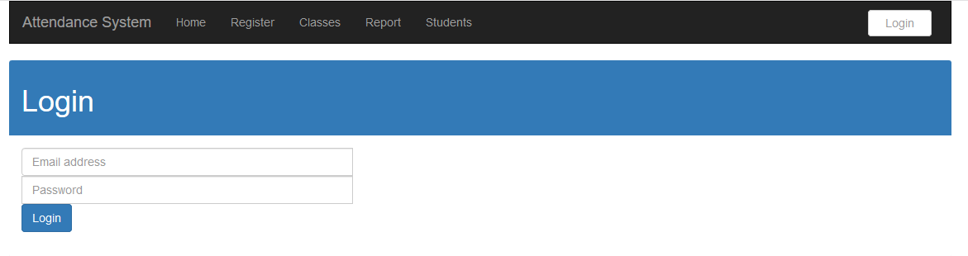

Enter the email and password to login

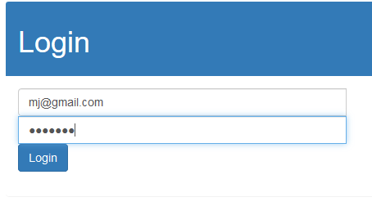

After login, the system will redirect to this page below.

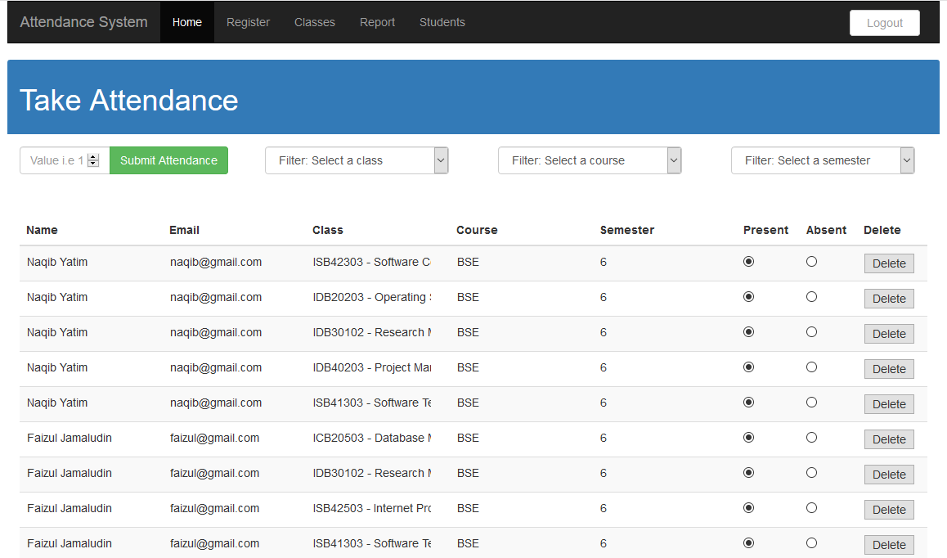

Figure 1

1. Register a student

Click Register on the header, it will bring user to this page.

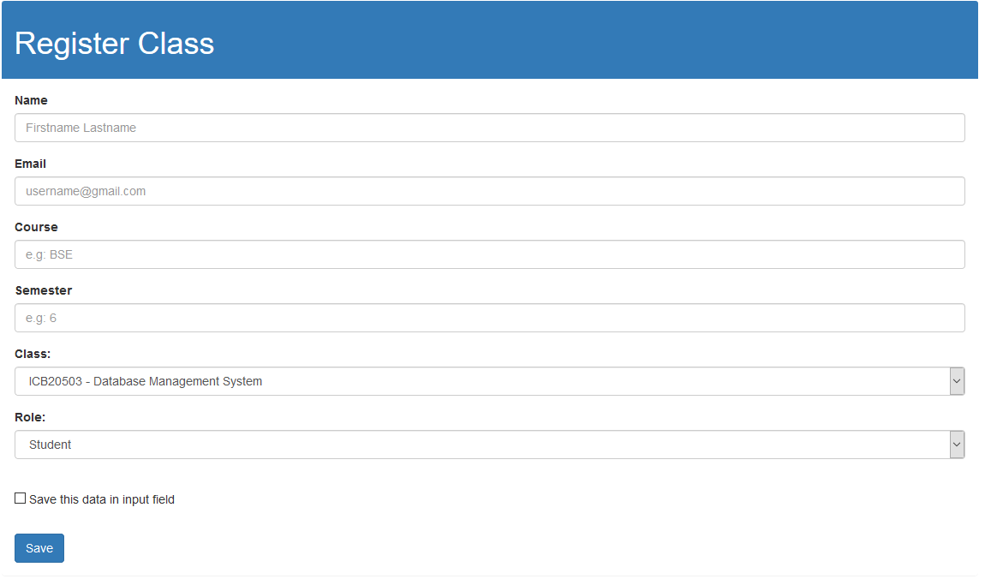

Fill in the details and depending on your need, you can set roles to student or teacher. If you want to create an account to login to the system just set the roles to the teacher. Example below registered as a student. Click save.

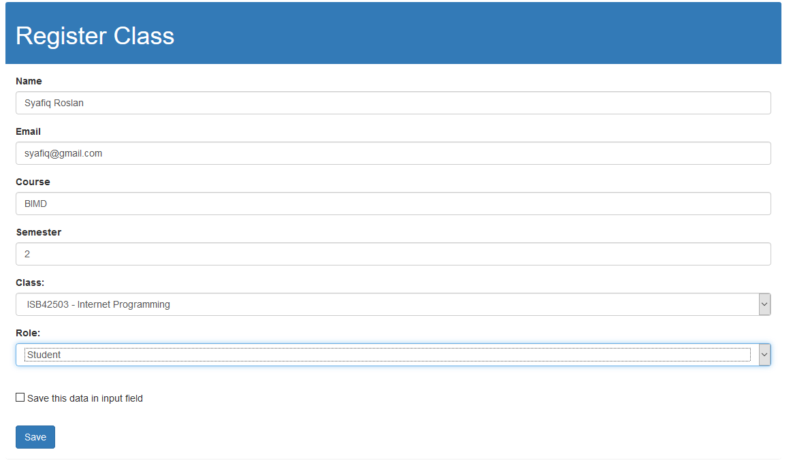

The saved data will show up in the list of attendance. You can delete the student if needed.



1. Creating a new class

Click Classes on Figure 1 to create a new class.

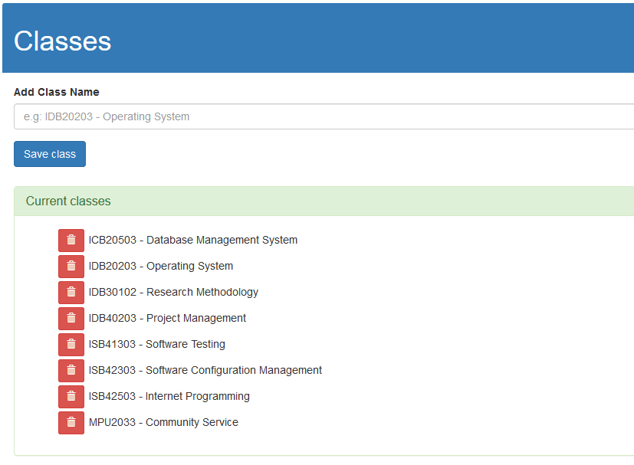

Enter the new class you wish to enter and click save

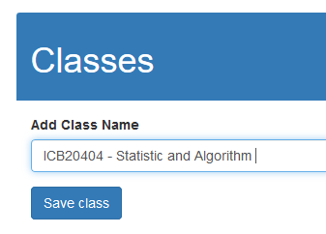

The new class is then saved into the list

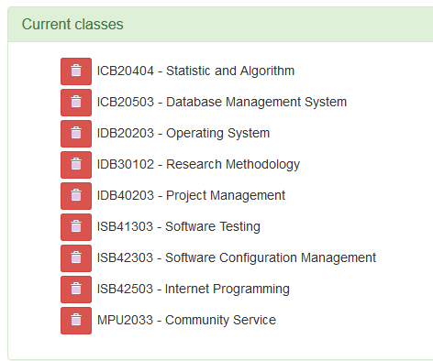

1. Taking an attendance

Back on home page, in order to take attendance, you can select either three filters.



The first filters enable you to select class that available and already created prior to this guide.

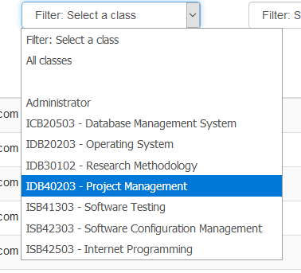

Second filters allow to filter students by course

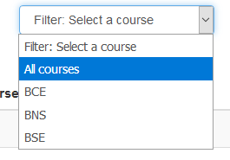

And last filters you can sort by semesters.

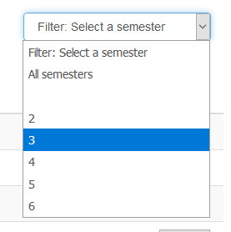

To take attendance, select one of the filters above and click submit attendance. The list of students available will be saved into the list of attendance.

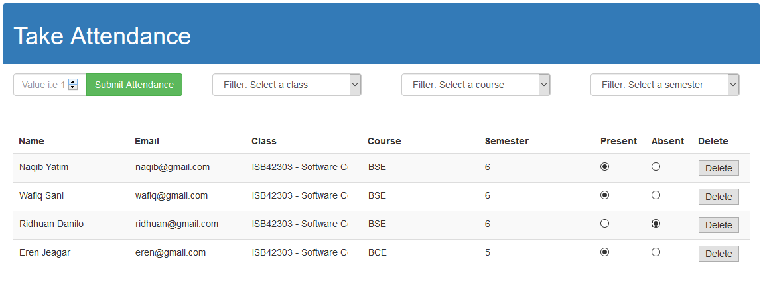

1. Print list of students.

Teacher can export all the list of students from the database into PDF format or hardcopy. Click on student button on top of the header.

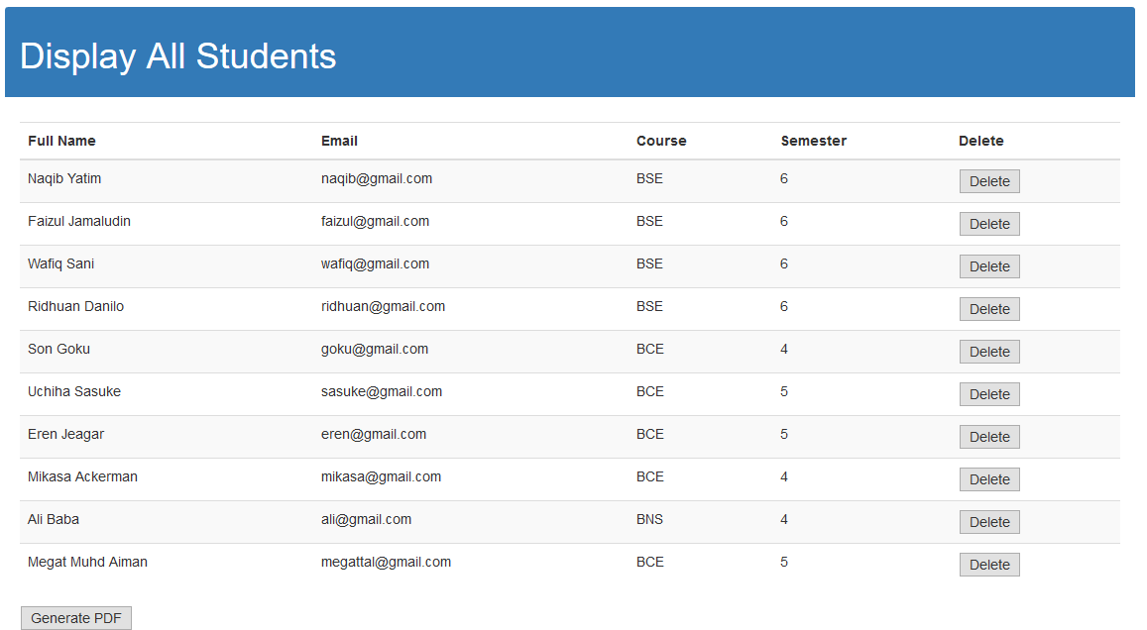

Click on generate PDF to convert it into PDF format and print it.

